# Marketing Analytics: Assignment 6

By Preethi Susan Abraham

1 and 2. Analyse the data from the communications test. What campaign idea is the winner? And What metric or metrics did you base your decision on?

🡪 The campaign ‘COBRA’ seems to be the campaign winner. Here, I considered three metrics to come to the conclusion that Cobra is the best campaign.

The first metric is the rating given by customers regarding their overall impression after seeing the product (Figure 1). By computing the mean values of this rating, it can be seen that the campaign titled ‘Cobra’ has the highest mean rating compared to the other campaigns. Overall impression rating is the major criteria which helps determine if our campaign is successful or not.

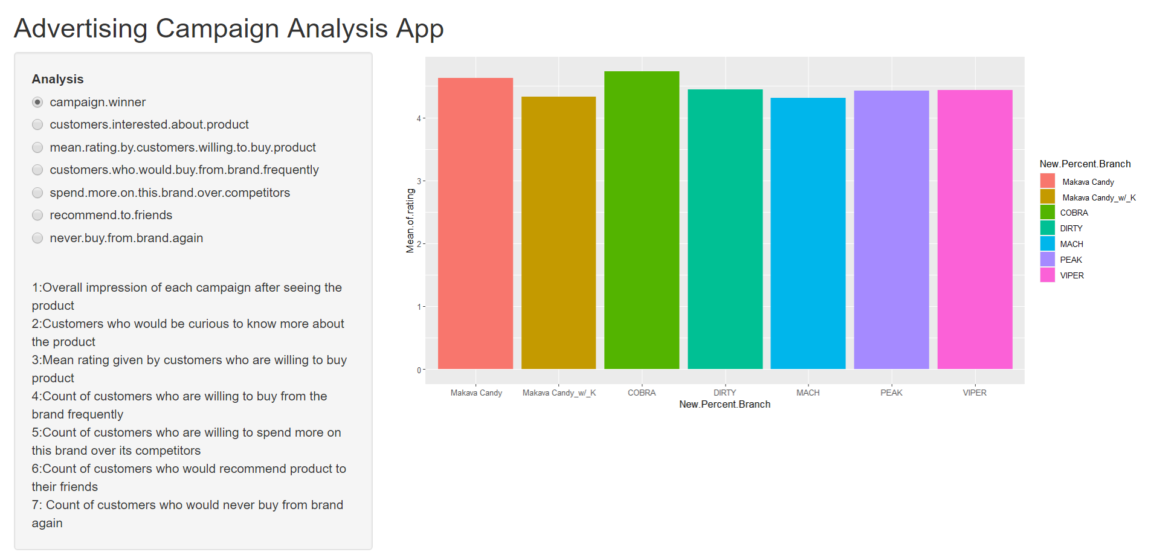

Figure 1

Apart from this, I considered the customers who have given a rating above 5 when they were asked the question ‘I would go pick up the product to find out more about it’. Since the rating scale is from 1 to 7, we can say that customers who have given a rating of 5 or above for this question would be really interested to pick up the product from the store and find out more about it. Figure 2 shows that the campaign ‘Dirty’ has the highest number of customers who gave a rating of 5 or above. However, the ‘COBRA’ campaign still seems to be generating a good amount of interest among customers.

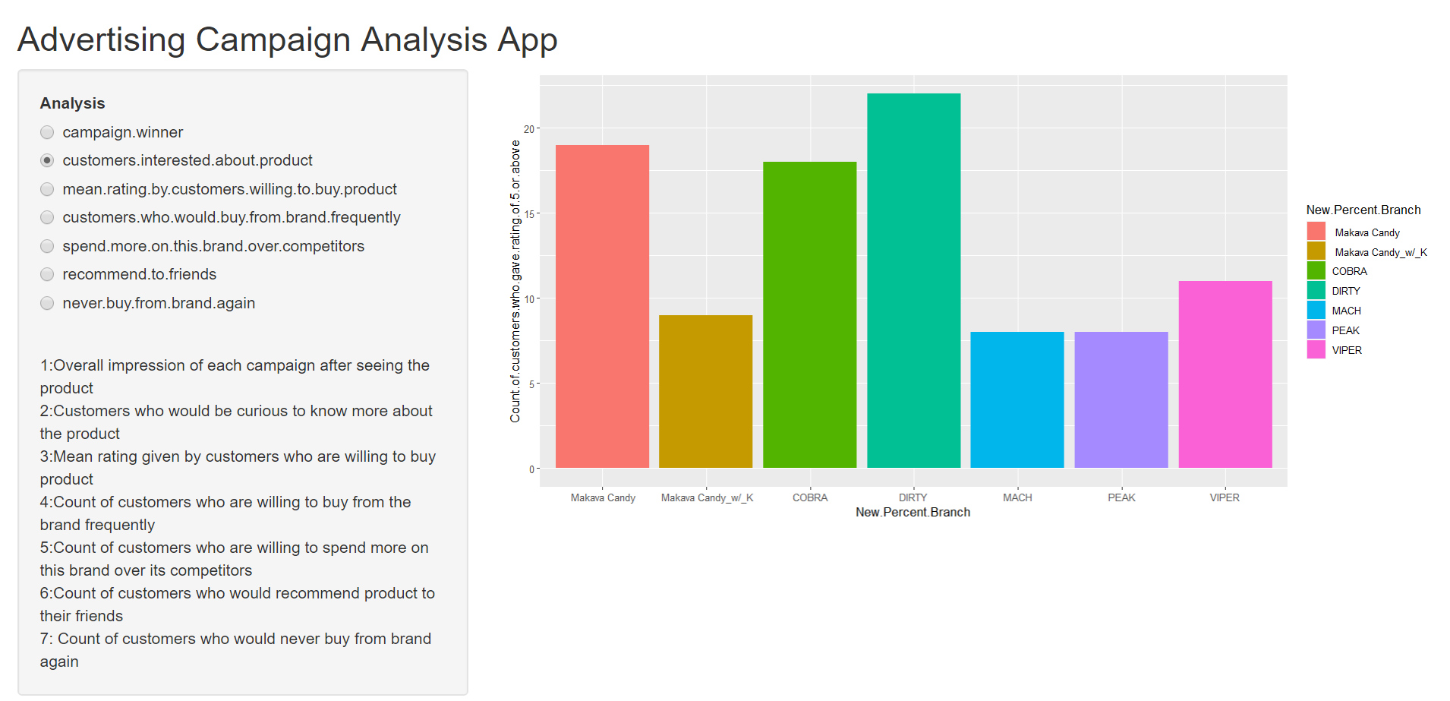

Figure 2

The third metric which I considered to come to the conclusion that ‘COBRA’ is the best campaign would be the ratings given by customers for the question ‘I would go pick up the product with the intention of buying it’. By taking the mean of all the customer ratings across different campaigns, it can be seen that the mean rating of ‘COBRA’ seems to be the highest compared to others (Figure 3).

Since the overall impression and the willingness shown by customers to pick up the product and buy it for ‘COBRA’ are the highest, we can say that this is the best campaign.

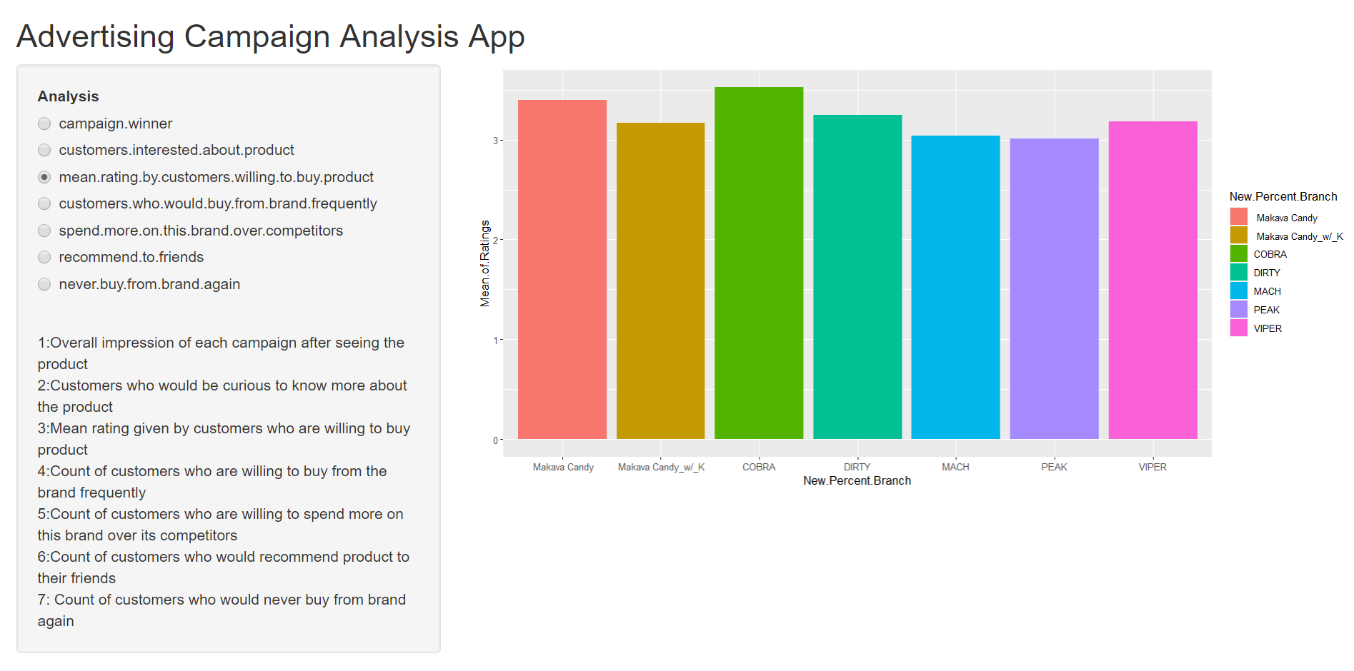

Figure 3

3. Using the data, what kind of impact should the campaign have on sales?

🡪 The ‘COBRA’ campaign seems to be having a highly positive impact on sales. This can be seen from the graphs below:

Figure 4 shows the count of customers who are willing to buy the product more frequently. It can be seen the ‘COBRA’ has the second highest count of customers who would be willing to purchase more frequently from this brand. This shows that the ‘COBRA’ campaign is performing well and ensuring that customers would buy the brand as frequently as possible.

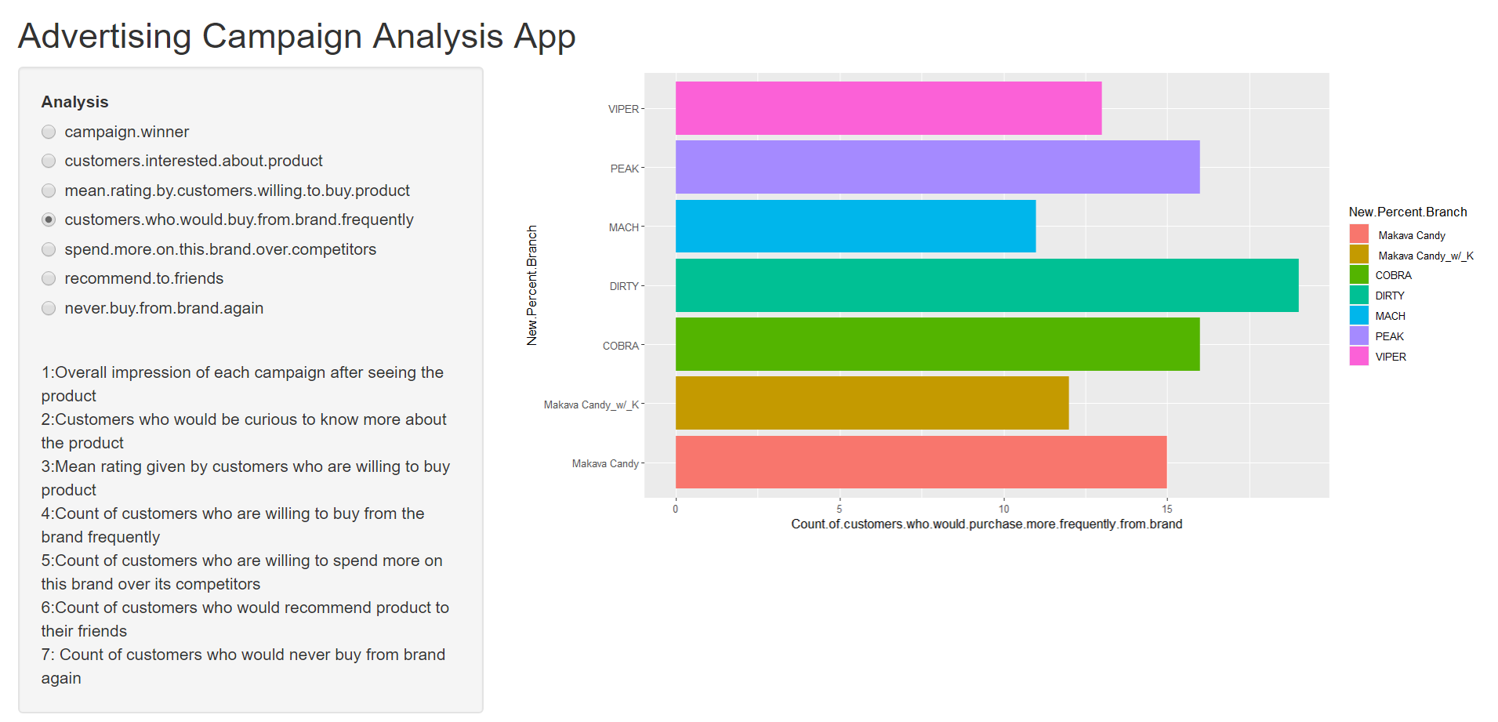

Figure 4

Figure 5 shows that customers are willing to spend more on the brand compared to its competitors after seeing the ‘COBRA Campaign’. This shows that customers seem to really trust the brand such that they are ready to spend more.

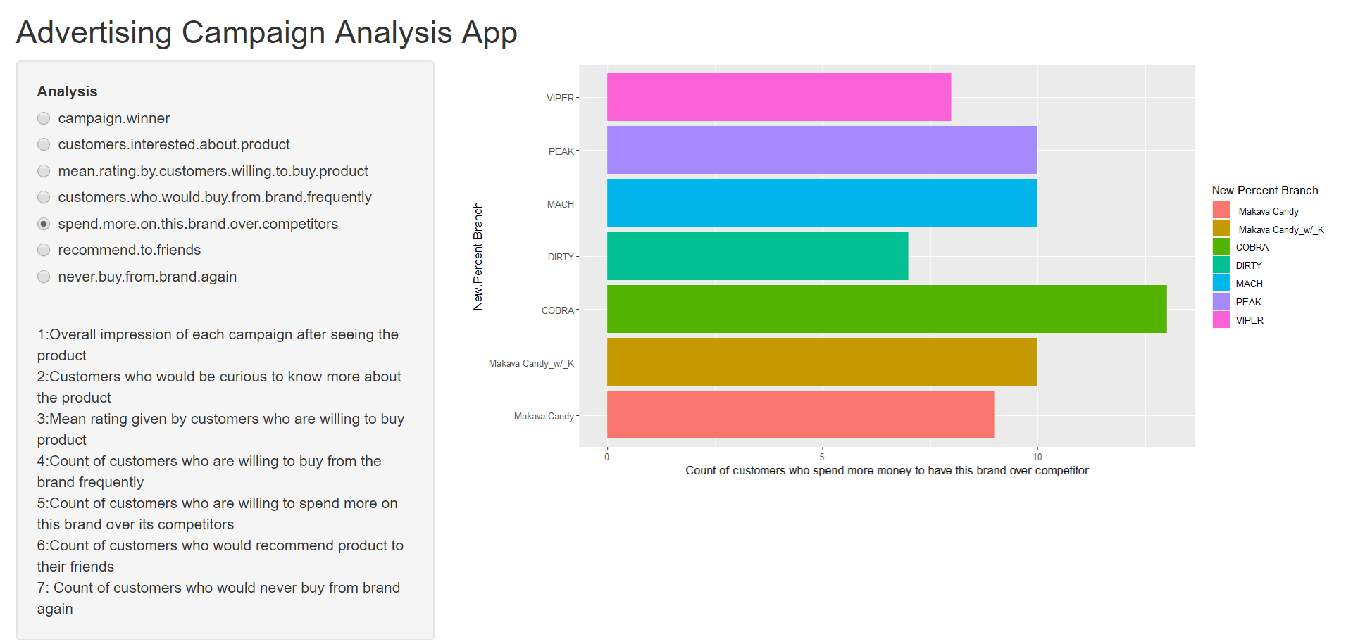

Figure 5

Figure 6 shows that the highest number of customers would recommend the brand to their friends after having viewed the ‘COBRA’ and ‘Makava Candy’ advertising campaign. The ‘Cobra’ campaign seems to be doing well as it seems to be enticing the brand’s existing customers to recommend the product to their friends.

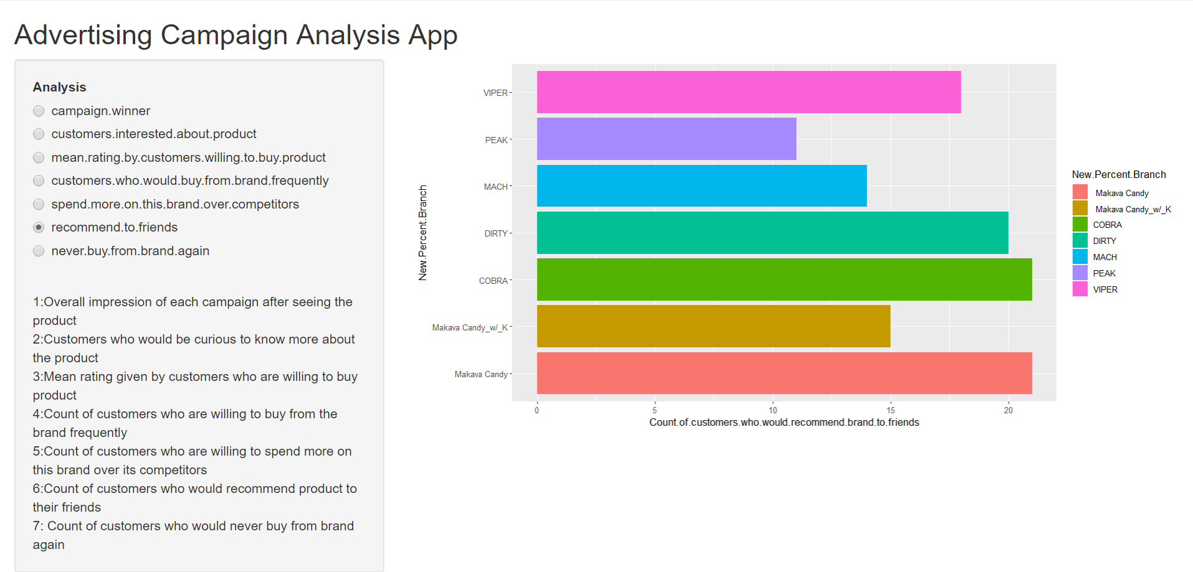

Figure 6

Figure 7 shows that ‘Mach’ advertising campaign seems to be the worst. By viewing this campaign, most customers seem to never want to buy from the brand again. Whereas in the case of the ‘COBRA’ campaign, it can be seen that not many customers will say that they don’t want to buy from the brand again. The ‘COBRA’ campaign seems to be the best campaign which our client should consider.

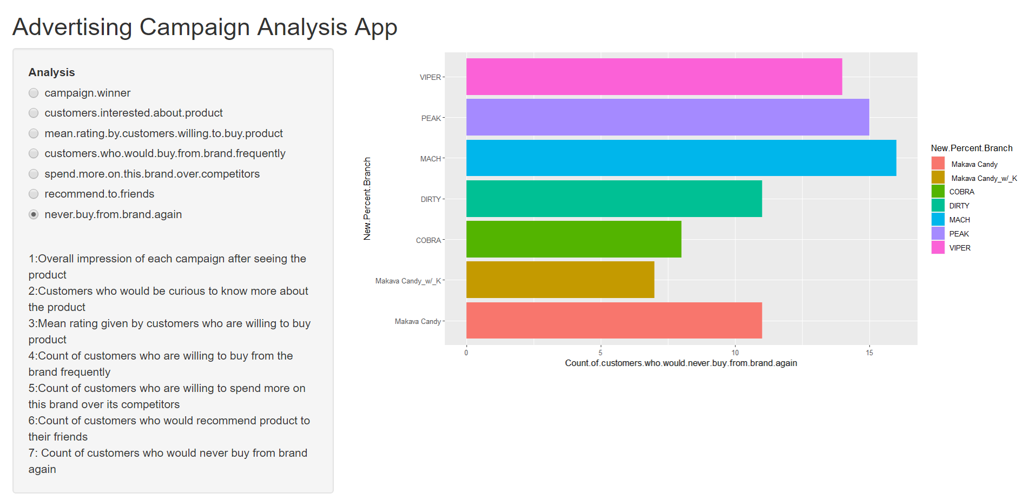

Figure 7